**Movie Ticketing Bot Powered by IBM Watson Assistant**

1. **Introduction**
   1. **Overview**

A **chatbot** is a [software](https://en.wikipedia.org/wiki/Software_agent) application used to conduct an on-line chat [conversation](https://en.wikipedia.org/wiki/Conversation) via text or [text-to-speech](https://en.wikipedia.org/wiki/Speech_synthesis), in lieu of providing direct contact with a live human agent, designed to convincingly simulate the way a human would behave as a conversational partner.

The term "ChatterBot" was originally coined by [Michael Mauldin](https://en.wikipedia.org/wiki/Michael_Loren_Mauldin) (creator of the first [Verbot](https://en.wikipedia.org/wiki/Verbot" \o "Verbot)) in 1994 to describe these conversational programs.

* 1. **Purpose**

The main purpose of this project is to create a chatbot for the Booking of the movie tickets at your desired place, time, day, etc. To achieve this, we have to create a IBM Watson Assistant using IBM Cloud Services.

1. **Theoretical Analysis**
   1. **Flow Chart**

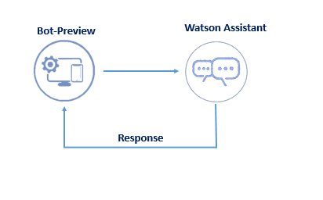

* 1. **Software Designing**
* IBM Cloud
* IBM Watson Assistant

1. **WorkFlow**
   1. **Intents**

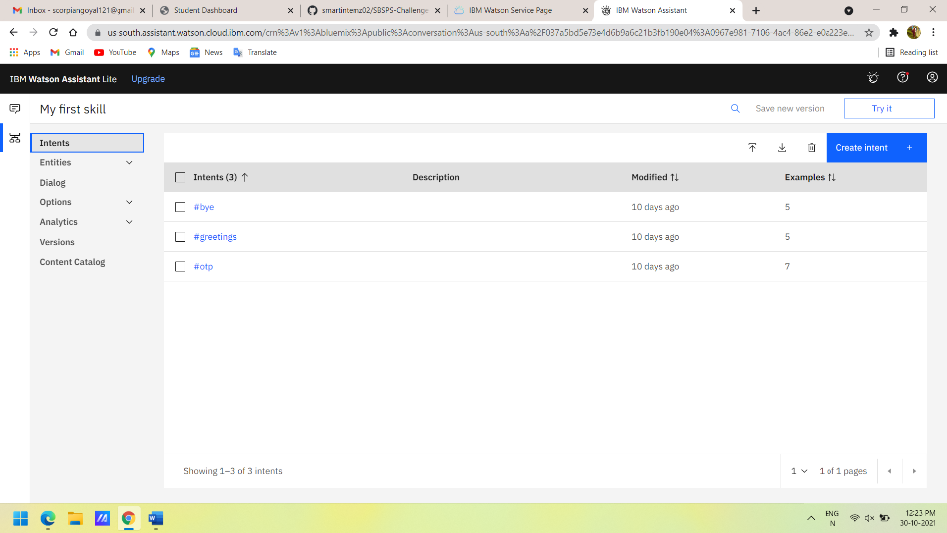

* 1. **Entities**

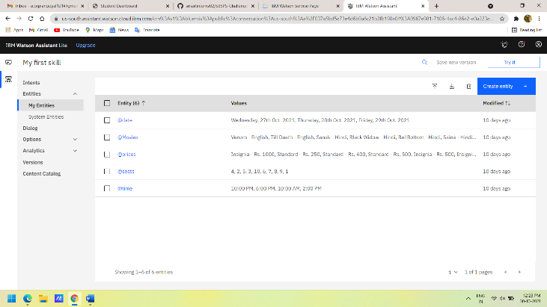

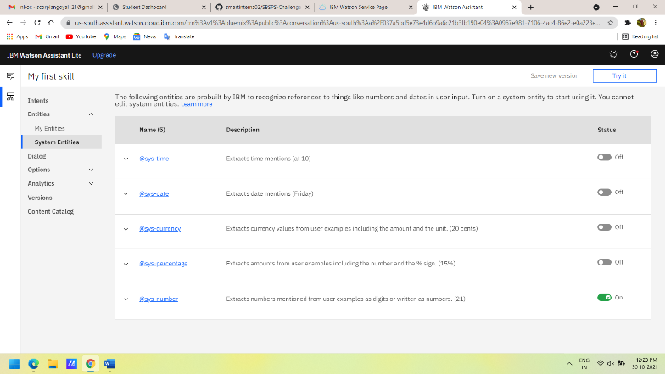

* 1. **Dialog**

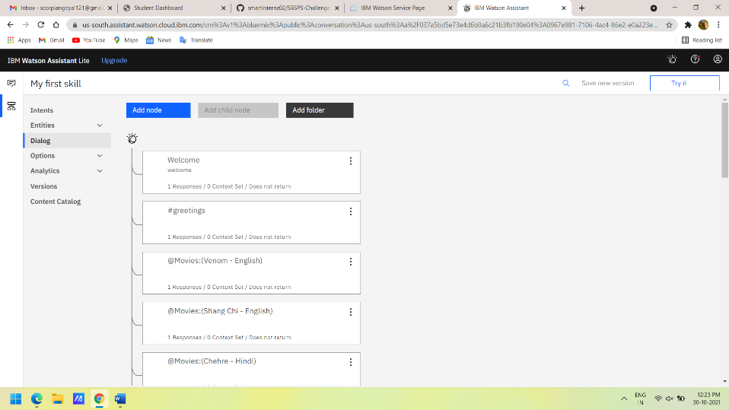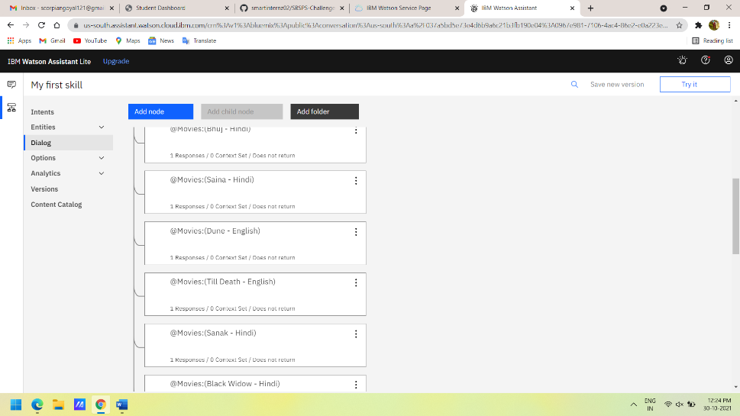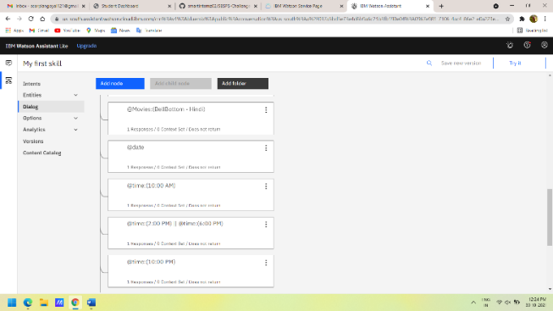

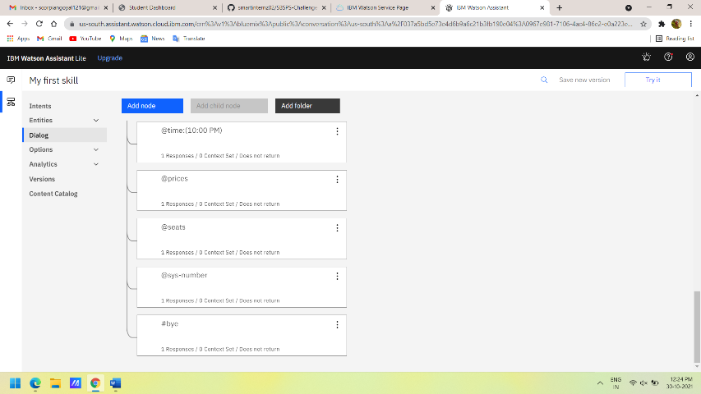

1. **Result**

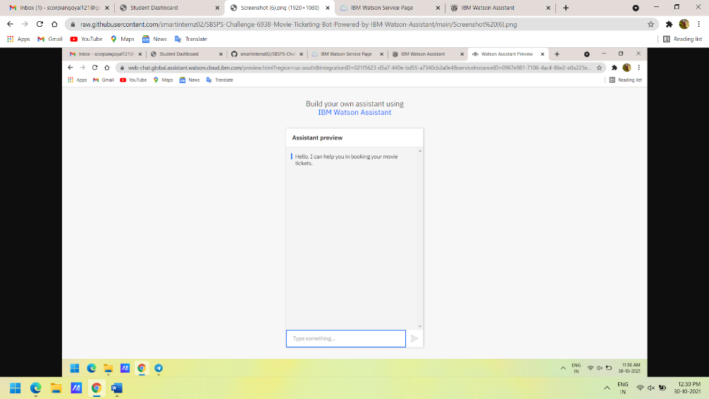

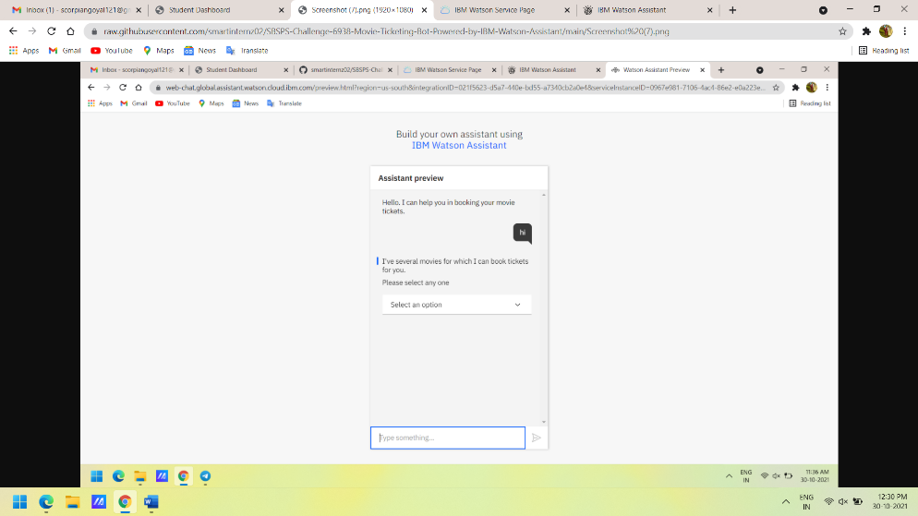

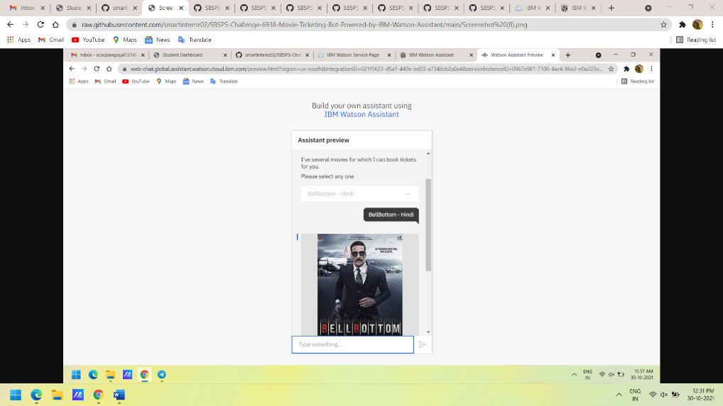

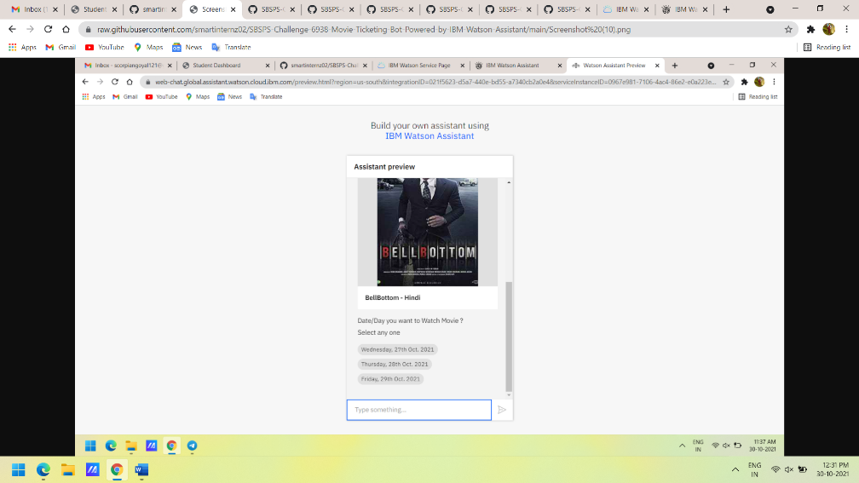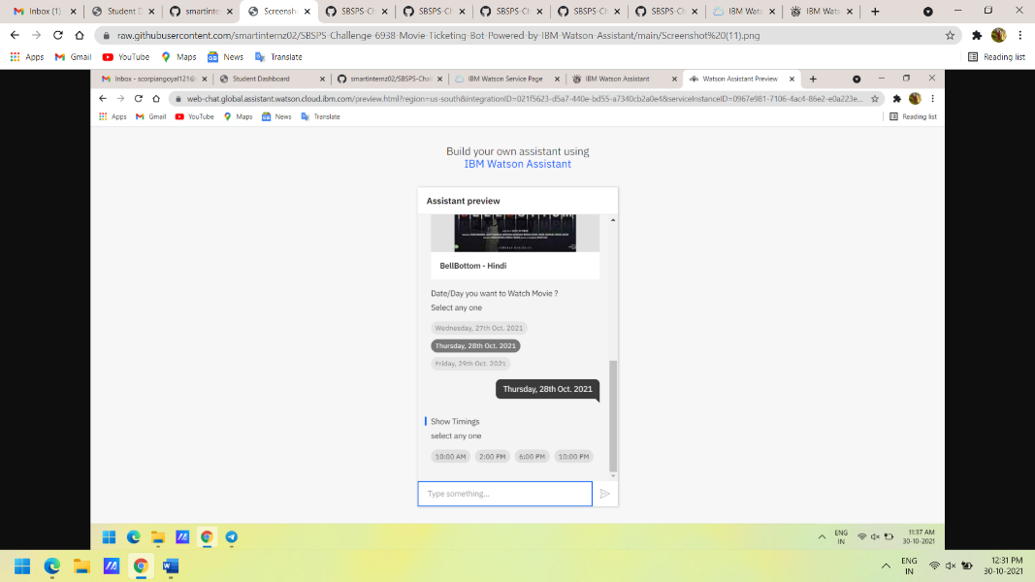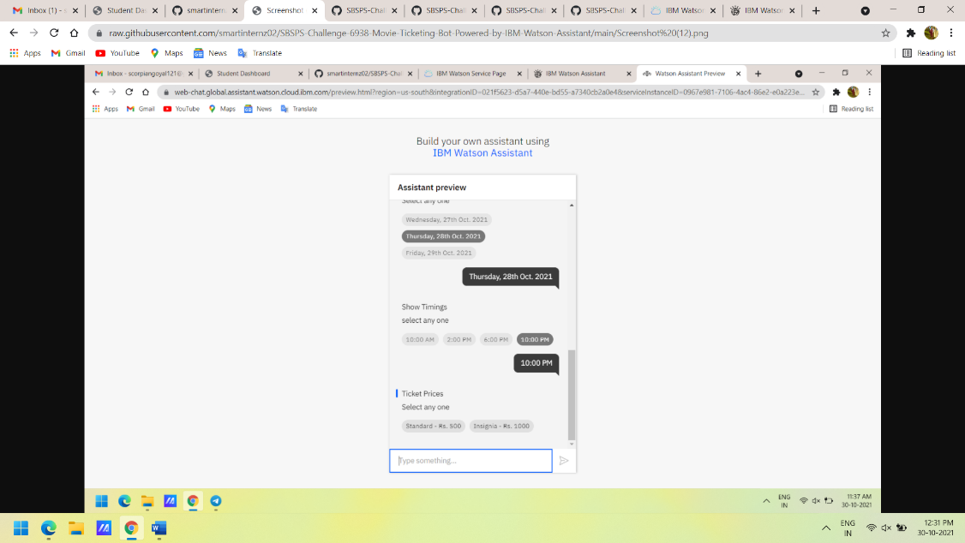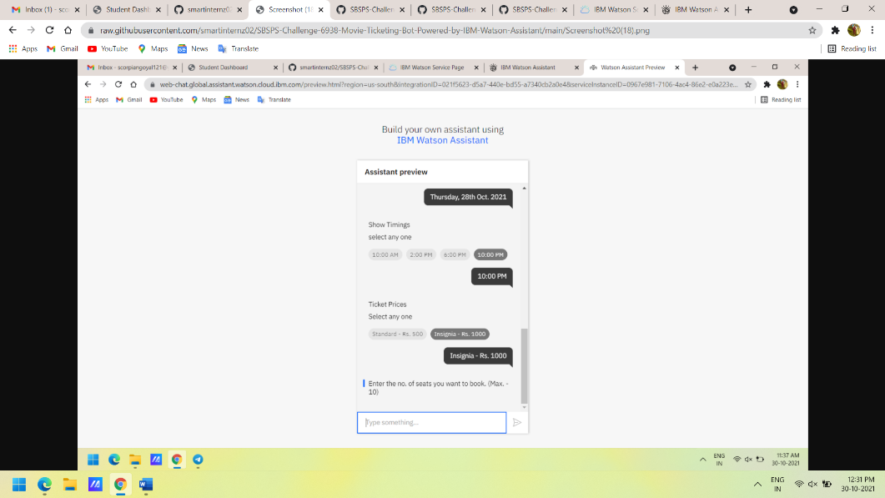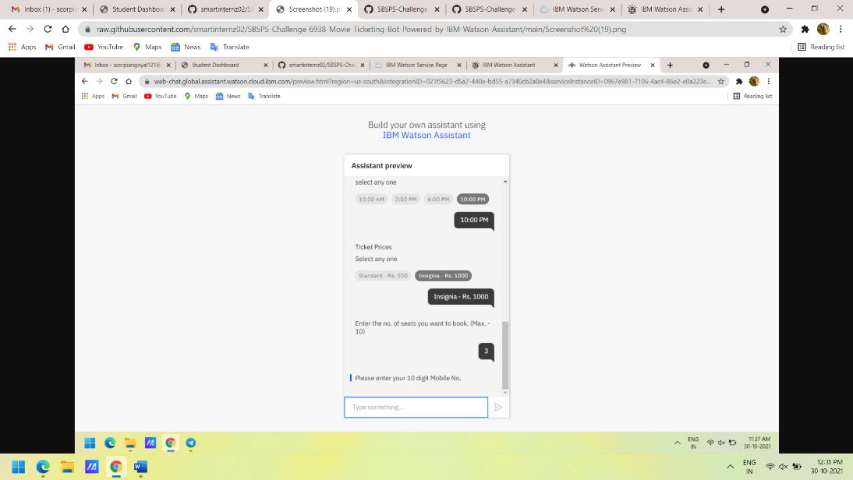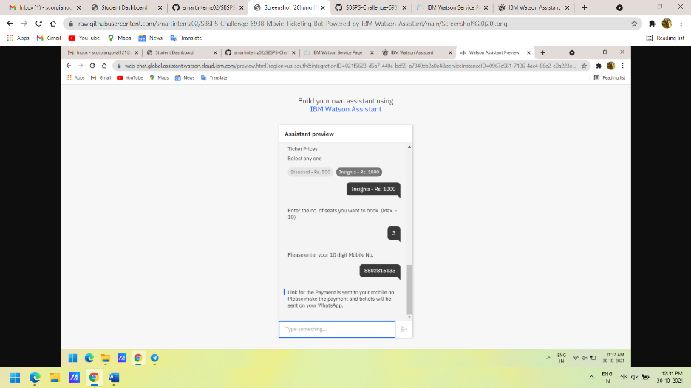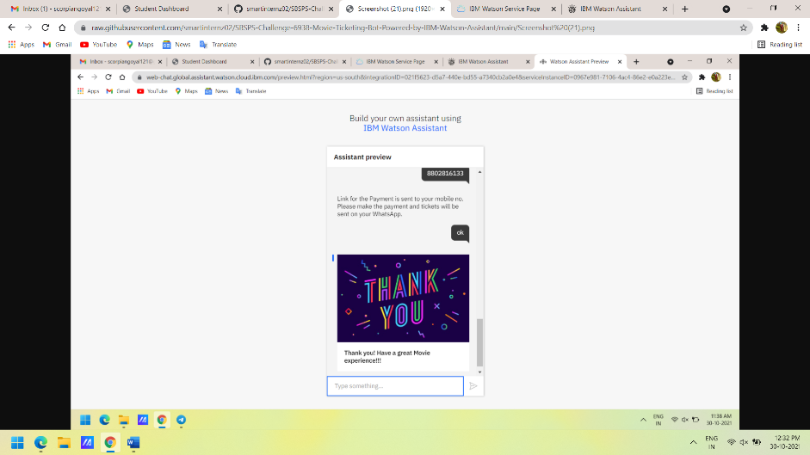

1. **Advantages And Disadvantages**
   1. **Advantages**

* Easy to use and Apply
  1. **Disadvantages**
* Emotions of Costumer/User is not considered.

1. **Applications**

Can be used in any movie ticket booking websites and mobile apps.

1. **Conclusion**

Developed Movie Ticket Booking Chatbot using IBM Watson Assistant

1. **Future Scope**

Many more features can be integrated to give a better user experience.

1. **Appendix**
   1. **Video Demo**

<https://youtu.be/3Sa7VrkWGGA>

* 1. **Source Code**

<https://github.com/smartinternz02/SBSPS-Challenge-6938-Movie-Ticketing-Bot-Powered-by-IBM-Watson-Assistant/blob/main/skill-My-first-skill.json>